Edits from 3.1.3

1. Open the Git Shell application.
2. Provide Git a *name* so commits will be properly labeled. Use the same name as the username provided when creating your GitHub account (see Section 3.1.2.1). Type everything after the $ here:

$ git config --global user.name "YOUR NAME"

e.g. git config --global user.name "John Doe"

1. Tell Git the *email address* that will be associated with the Git commits. The email provided should be the same one used to create your GitHub account (see Section 3.1.2.1).

$ git config --global user.email "*YOUR EMAIL ADDRESS*"

e.g. git config --global user.email [johndoe@example.com](mailto:johndoe@example.com)

If problems arise with this, more detailed instructions can be found at <http://git-scm.com/book/en/v2/Getting-Started-First-Time-Git-Setup>.

Edits from 4.1.2

**To install Eclipse:**

1. Go to <https://www.eclipse.org/downloads/>

2. Select the link (32 bit or 64 bit) for your platform from the Eclipse Installer box at the top of the page.

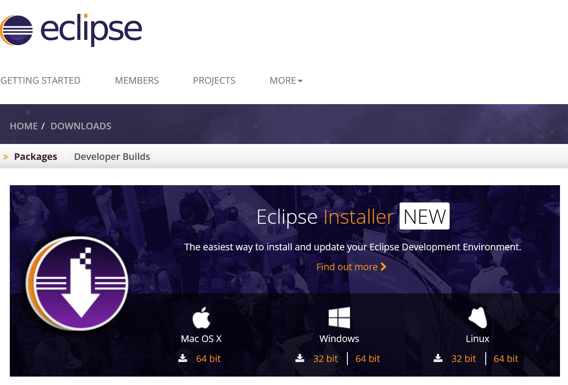

3. Click Download from the next screen.

4. For Windows users, after the Eclipse Installer executable has finished downloading it should available in your download directory. Start the Eclipse Installer executable. You may get a security warning to run this file. If the Eclipse Foundation is the Publisher, you are good to select Run.

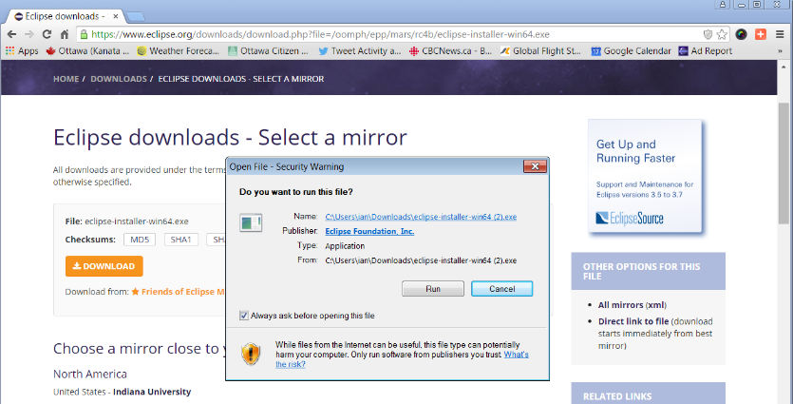For Mac and Linux users, you will still need to unzip the download to create the Installer. Start the Installer once it is available.

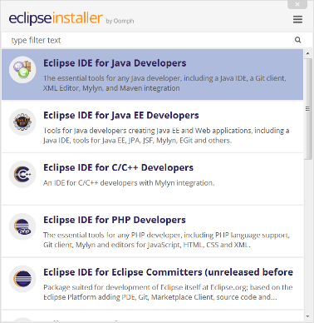5. The new Eclipse Installer shows the packages available to Eclipse users. You can search for the package you want to install or scroll through the list. Select and click on the package you want to install.

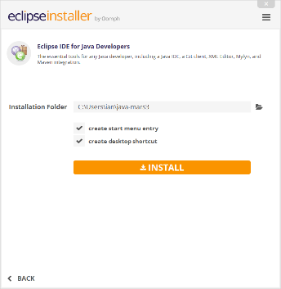6. Specify the folder where you want Eclipse to be installed. The default folder will be in your User directory. Select ‘Install’ button to begin the installation.